# 7.Hell's Kitchen

You will be given an **array of strings**, which represents a **list** of **all** the **restaurants** with their workers.



When the [**Send**] button is clicked:

* Display the **best** **restaurant** of all the **added** **restaurants** with its **average** **salary** and **best** **salary**.
* If there is a restaurant in the input array that is added more than once, you need to add new workers to the old ones and **update** the values of the **average salary** and the **best** **salary**.
* The best restaurant is the restaurant with the **highest** **average** salary. If two restaurants have the **same** average salary the best restaurant is the **first** one added.
* Display **all** workers in the **best** **restaurant** with their **salaries**.

The best restaurant's workers should be **sorted** by their **salaries** in **descending** order.

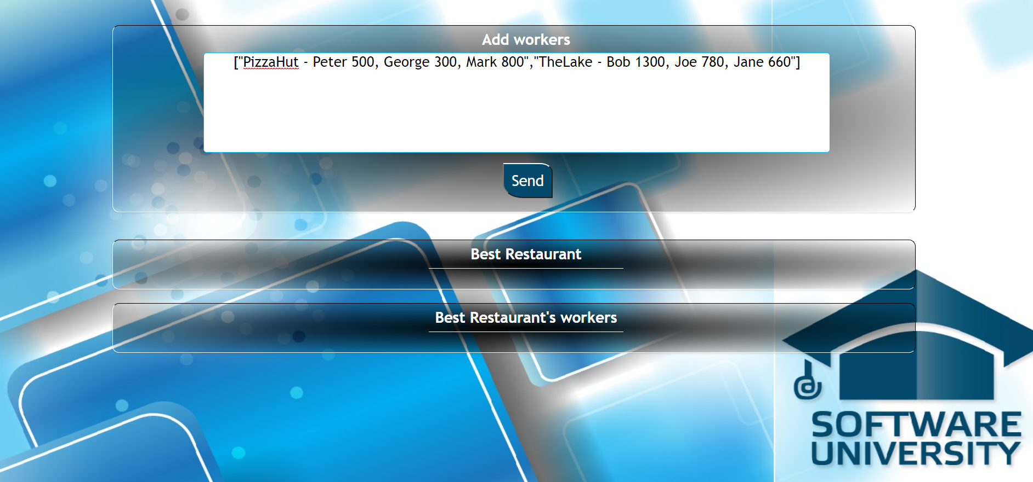

### Input

The input will be received from the given **textarea** in the form of an **array** of **strings**. Each string represents a **restaurant** with its **workers**: **["Mikes - Steve 1000, Ivan 200, Paul 800", "Fleet - Maria 850, Janet 650"]**

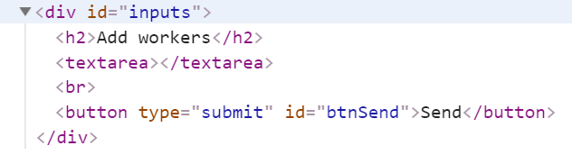

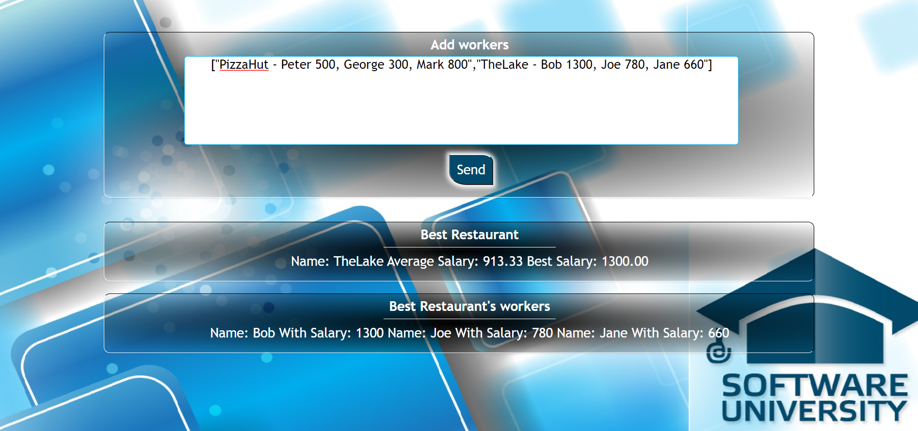

### Output

* The output contains **two strings**
  + The first one is **the best restaurant** in the format:

**`Name: {restaurant name} Average Salary: {restaurant avgSalary} Best Salary: {restaurant bestSalary}`**

**avgSalary** and **bestSalary** must be formatted to the **second decimal point.**

* + The second one is all the workers in that restaurant in the following format:

**`Name: {worker name} With Salary: {worker salary} Name: {worker2 name} With Salary: {worker2 salary} Name: {worker3 name} With Salary: {worker3 salary}…`**

Output strings must be set like **text content** in the following elements:

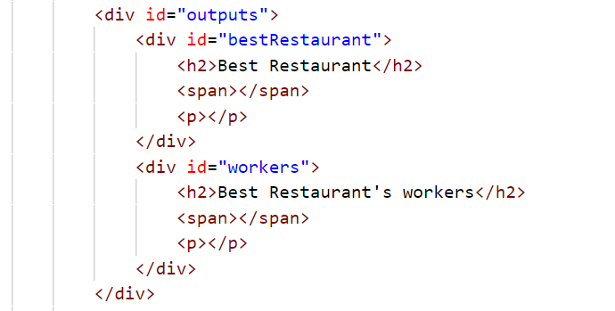

### Constraints

* The workers will be always **unique**

### Examples

|  |  |  |
| --- | --- | --- |
| **Input** | **Output** | **Comment** |
| **["PizzaHut - Peter 500, George 300, Mark 800",**  **"TheLake - Bob 1300, Joe 780, Jane 660"]** | **Name: TheLake Average Salary: 913.33 Best Salary: 1300.00 Name: Bob With Salary: 1300 Name: Joe With Salary: 780 Name: Jane With Salary: 660** | **The added restaurants are: TheLake and PizzaHut.  TheLake has average salary: (1300+780+660)/3= 913.33, and PizzaHub has average salary:  (500+300+800)/2=533.33.  So the best restaurant is TheLake.** |
| **["Mikes - Steve 1000, Ivan 200, Paul 800","Fleet - Maria 850, Janet 650"]** | **Name: Fleet Average Salary: 750.00 Best Salary: 850.00 Name: Maria With Salary: 850 Name: Janet With Salary: 650** |  |